**PROJECT REPORT**

***Submitted by***

**Shaurya Singh Srinet (RA2111032010006)**

***Under the Guidance of***

**Dr. Prabakeran S.**

**Assistant Professor, Networking and Communications**

***In partial satisfaction of the requirements for the degree of***

## **BACHELOR OF TECHNOLOGY**

**in**

**COMPUTER SCIENCE ENGINEERING**

**with specialization in Internet of Things**

**SCHOOL OF COMPUTING**

# **COLLEGE OF ENGINEERING AND TECHNOLOGY**

**SRM INSTITUTE OF SCIENCE AND TECHNOLOGY**

**KATTANKULATHUR - 603203**

**October 2023**

SRM INSTITUTION OF SCIENCE AND TECHNOLOGY

KATTANKULATHUR-603203

**BONAFIDE CERTIFICATE**

Certified that this Project Report titled **“Static Website Hosting on S3 Bucket”** is the bonafide work done by **Shaurya Singh Srinet (RA2111032010006)** whocompleted the project under my supervision. Certified further, that to the best of my knowledge the work reported herein does not form part of any other work.

| **SIGNATURE**  Dr. Prabakeran S.  **Course Faculty**  **Assistant Professor**  Department of Networking and Communications  SRMIST | **SIGNATURE**  Dr. Annapurani P. K.  **Head of the Department**  Department of Networking and Communications  SRMIST |
| --- | --- |

i

**TABLE OF CONTENTS**

|  |  |  |
| --- | --- | --- |
| **S. No** | **CONTENTS** | **PAGE NO** |
| 1. | Problem Statement | 1 |
| 2. | Modules of Project | 2 |
| 3. | Diagrams |  |
|  | 1. Use case Diagram | 3 |
|  | 1. Class Diagram | 4 |
|  | 1. Sequence Diagram | 5 |
|  | 1. Collaboration Diagram | 6 |
|  | 1. State Chart Diagram | 7 |
|  | 1. Activity Diagram | 8 |
|  | 1. Package Diagram | 9 |
|  | 1. Component Diagram | 10 |
|  | 1. Deployment Diagram | 11 |
| 4. | Input/Output Screenshots | 12 |
| 5. | Conclusion and Results | 15 |
| 6. | References | 16 |

**PROBLEM STATEMENT**

In today's digital age, organizations and individuals often require a cost-effective and efficient method to host static websites. Hosting a static website not only necessitates reliable storage but also demands a scalable and highly available infrastructure to ensure seamless access for users. The objective of this mini project is to explore and implement static website hosting using Amazon S3 (Simple Storage Service) as a solution.

**The primary problem to be addressed in this project can be defined as follows:**

"How can we effectively host a static website on an Amazon S3 bucket, ensuring optimal performance, scalability, security, and cost-efficiency, while providing a detailed guide for others to replicate the process?"

**This problem encompasses several key aspects:**

1. **Hosting Platform Selection**: Assessing the choice of Amazon S3 as a hosting platform, considering its capabilities, pricing structure, and benefits for static websites.
2. **Website Setup**: Detailing the process of setting up a sample static website, including HTML, CSS, and JavaScript files, that will be hosted on the S3 bucket.
3. **Bucket Configuration**: Configuring the Amazon S3 bucket for website hosting, including defining permissions, enabling static website hosting features, and setting up custom error documents.
4. **Scalability**: Exploring the scalability options within Amazon S3, such as utilizing CloudFront (Content Delivery Network) to enhance website performance.
5. **Security**: Ensuring the security of the hosted website, including access control, data encryption, and best practices for mitigating security risks.
6. **Cost-Efficiency**: Evaluating the cost implications of hosting a static website on Amazon S3 and implementing strategies to optimize costs.
7. **Documentation and Replication**: Creating a comprehensive project report and documentation that serves as a guide for others looking to host static websites on Amazon S3.

By addressing these aspects, the project aims to provide valuable insights and a practical guide for individuals and organizations seeking an effective and economical solution for hosting static websites on Amazon S3, thereby enhancing their online presence and ensuring an optimal user experience.

**1**

**MODULES OF THE PROJECT**

Modules for the "Static Website Hosting on Amazon S3 Bucket" Project:

1. **Platform Evaluation**: Assess the suitability of Amazon S3 for hosting static websites.
2. **Website Setup**: Create and organize a sample static website.
3. **Bucket Configuration**: Set up an Amazon S3 bucket for website hosting and configure settings.
4. **Content Upload**: Upload website files to the S3 bucket.
5. **Scalability and CDN Integration**: Implement Amazon CloudFront for improved website performance.
6. **Security Implementation**: Secure the S3 bucket with access controls and encryption.
7. **Cost Optimization**: Monitor and reduce hosting costs.
8. **Performance Testing**: Test website loading speed and optimize as needed.
9. **Documentation** **and** **User Guide**: Prepare a detailed guide for replicating the hosting process.

These key modules form the structure of the Power Calculation Web Application project, ensuring a functional, secure, and user-friendly application while effectively utilizing AWS services for core functionality.

**2**

**DIAGRAMS**

**USE CASE DIAGRAM**

A use case diagram for the "Static Website Hosting on Amazon S3 Bucket" project can help visualize the interactions between various actors and the system. In this context, the primary actors are typically the project team members and external users who interact with the system.

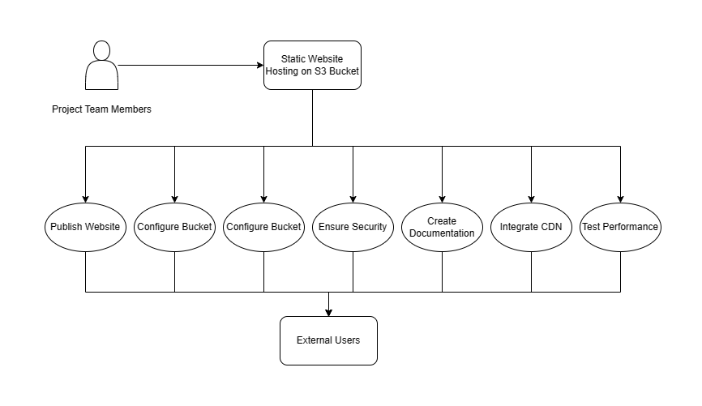

**Publish Website**: The project team uploads the website to the S3 bucket for hosting.

**Configure Bucket**: Team members set up S3 bucket settings, including permissions and configurations.

**Optimize Costs**: The team monitors and optimizes hosting costs.

**Ensure Security**: Security measures are implemented to protect the hosted website.

**Create Documentation**: Team members create user guides and documentation.

**Integrate CDN**: A CDN is added for improved website performance.

**Test Performance**: Performance testing is conducted to ensure fast website loading.

External users access the hosted website but do not directly engage in these use cases.

**3**

**CLASS CASE DIAGRAM**

In a class diagram for the "Static Website Hosting on Amazon S3 Bucket" project, we can illustrate the key classes and their relationships.

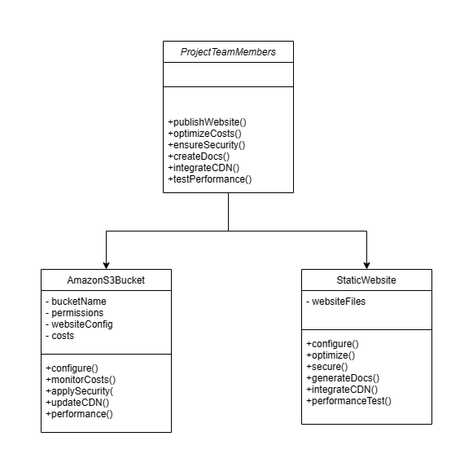

**ProjectTeam Members**: Represents the team members responsible for the project.

**StaticWebsite**: Represents the static website files, configurations, and actions.

**AmazonS3Bucket**: Represents the Amazon S3 bucket, including its name, permissions, configurations, and costs.

**Methods** **Used:**

**+publishWebsite():** Uploads the website to the S3 bucket.

**+configure():** Configures the S3 bucket and website settings.

**+optimizeCosts():** Monitors and optimizes hosting costs.

**+ensureSecurity():** Implements security measures.

**+createDocs():** Generates project documentation.

**+integrateCDN():** Adds a Content Delivery Network.

**+testPerformance():** Conducts performance testing.

This class diagram visually represents the main classes and their methods involved in the project. The project team members interact with the StaticWebsite and AmazonS3Bucket classes to achieve the project's objectives.

**4**

**SEQUENCE DIAGRAM**

Creating a sequence diagram for the "Static Website Hosting on Amazon S3 Bucket" project, which demonstrates the interactions and order of activities between the objects.

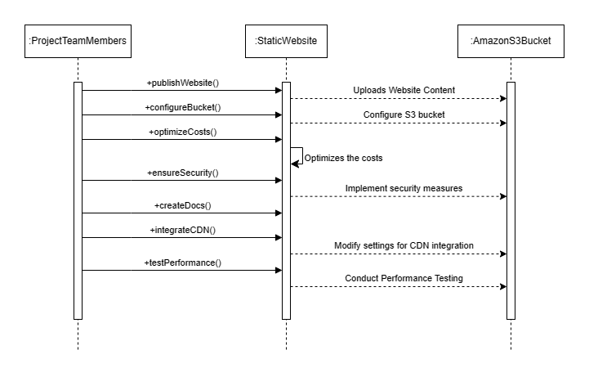

This sequence diagram illustrates the order of interactions and messages exchanged between the objects involved in the "Static Website Hosting on Amazon S3 Bucket" project. It starts with the Project Team Members invoking the publishWebsite() method on the Static Website, which, in turn, performs various internal actions and interactions with the Amazon S3 Bucket.

The diagram continues to show the flow of activities as the project team configures the bucket, optimizes costs, ensures security, creates documentation, integrates a CDN, and tests performance.

Each vertical line represents an object, and the horizontal arrows indicate the flow of messages and interactions between them. This sequence diagram helps visualize the step-by-step execution of activities within the project.

**5**

**COLLABORATION DIAGRAM**

A collaboration diagram, also known as a communication diagram, visually represents the interactions between objects or entities in the system.

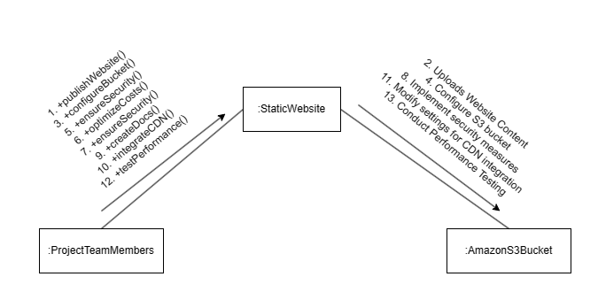

In this representation, the lines connect the objects, and the arrows indicate the flow of communication or interaction between them. The interactions correspond to the steps in the project, showing how the project team members interact with the Static Website and, when necessary, how the Static Website interacts with the Amazon S3 Bucket.

**6**

**STATE CHART DIAGRAM**

A state chart diagram depicts a state machine that defines the different operational states of the project. These states are influenced by both external and internal events, guiding the progression of the project through its various phases.

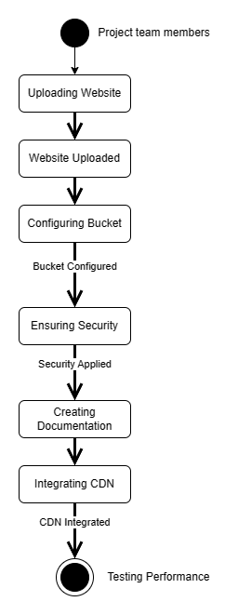

This state chart diagram provides a high-level view of the different states the system can go through during the "Static Website Hosting on Amazon S3 Bucket" project. The transitions between states reflect the progression of activities as the project unfolds.

**7**

**ACTIVITY DIAGRAM**

The activity diagram in UML is like an advanced flowchart, used to visually map the sequential flow of activities in the "Static Website Hosting on Amazon S3 Bucket" project. It shows how the project team moves from one task to the next as they work through the project's dynamic aspects.

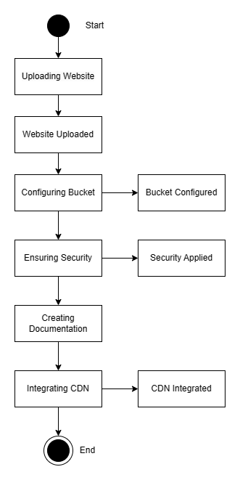

This activity diagram provides a visual representation of the sequential flow of activities and the corresponding actions in the "Static Website Hosting on Amazon S3 Bucket" project.

**8**

**PACKAGE DIAGRAM**

A package diagram provides a high-level view of the organization and structure of the project by grouping related elements into packages. In this case, the "Static Website Hosting on Amazon S3 Bucket" project can be represented with packages and their relationships.

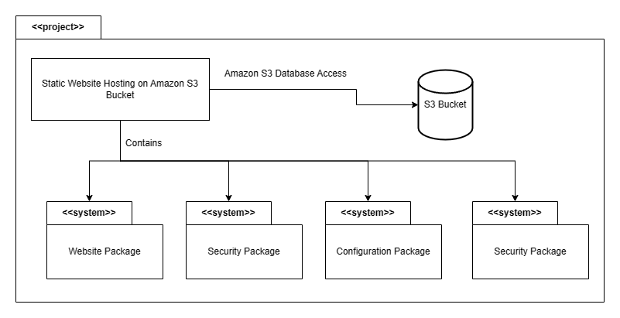

**<<Project>> Static Website Hosting on Amazon S3 Bucket**: This is the top-level package that represents the entire project.

**Website Package**: Contains elements related to the static website itself, such as the website files and web content.

**Configuration Package**: Includes elements related to the configuration of the Amazon S3 bucket and website settings.

**Security Package**: Encompasses elements associated with implementing security measures to protect the hosted website.

**Documentation Package**: Contains elements for creating project documentation, including user guides and reports.

This package diagram illustrates how the project is organized into distinct packages, each focusing on specific aspects of the "Static Website Hosting on Amazon S3 Bucket" project. The relationships between the packages provide a clear overview of the project's structure and organization.

**9**

**COMPONENT DIAGRAM**

A component diagram in UML depicts the high-level organization of components or modules in a system and their interconnections. For the "Static Website Hosting on Amazon S3 Bucket" project.

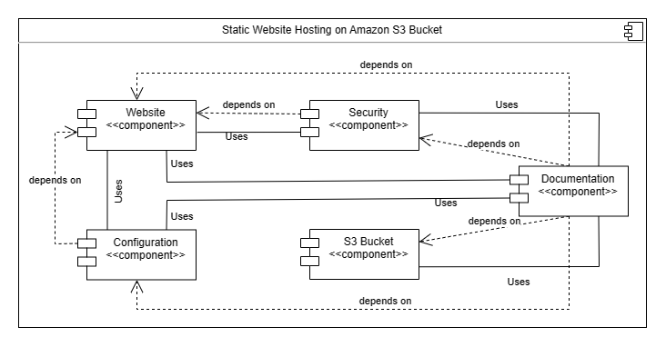

**Static Website Hosting Project:** The top-level component represents the entire project, including its main components.

**Website Component:** Represents the module responsible for the static website, including website files and content.

**Amazon S3 Bucket Component:** Represents the module responsible for the Amazon S3 bucket, managing hosting configurations, permissions, and file storage.

This component diagram provides a visual overview of the main modules within the project and how they interact. It highlights the relationship between the website component and the Amazon S3 bucket component, showing that they are integral parts of the overall project.

**10**

**DEPLOYMENT DIAGRAM**

A deployment diagram in UML illustrates the physical deployment of components and nodes in a system or project.

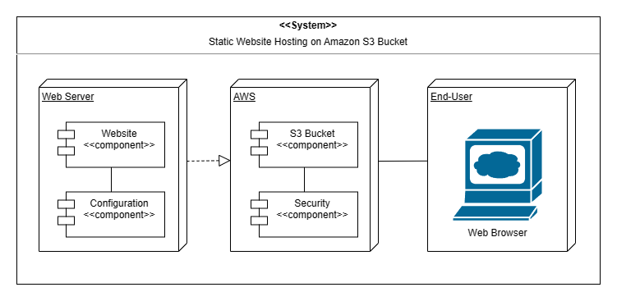

**<<System>> Static Website Hosting on Amazon S3 Bucket:** The top-level system element represents the entire project.

**Web Server (Hosting):** Represents the web server component responsible for hosting the static website. It serves website content to end users.

**Amazon S3 Bucket:** Represents the Amazon S3 bucket where the website files are stored.

**End User's Device (Browser):** Represents the devices used by end users to access the hosted static website via web browsers.

This deployment diagram provides a visual representation of the physical deployment of components in the project. It shows how the web server interacts with the Amazon S3 bucket to serve the website content to end users' devices.

**11**

**INPUT/OUTPUT SCREENSHOTS**

This screenshot illustrates the configuration settings of the Amazon S3 bucket used as a critical component in the "Static Website Hosting on Amazon S3 Bucket" project. It showcases the bucket's name, permissions, and various configurations that determine how the project's website is stored and accessed.

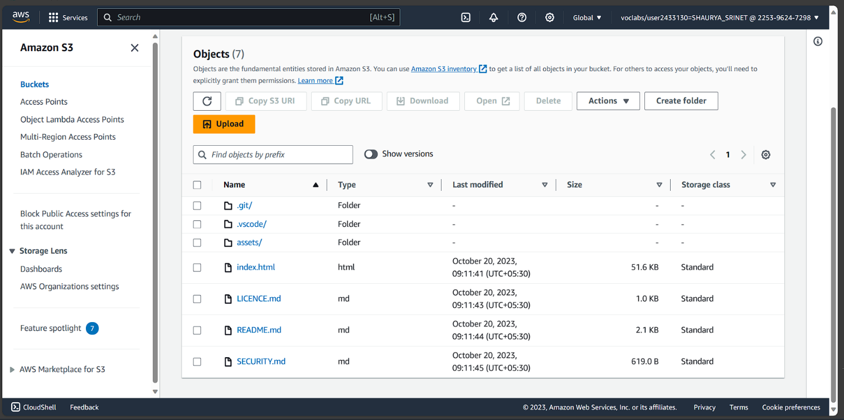

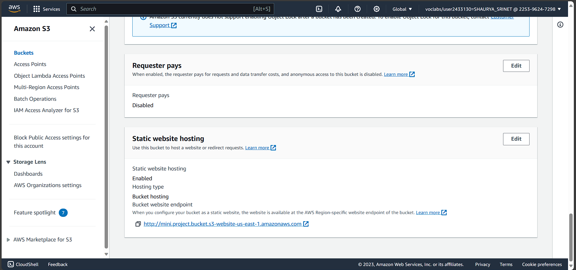

In summary, the homepage of the Power Calculation Web Application offers a straightforward and engaging interface. Users can quickly input their values, initiate calculations, and view results in real-time. The design and layout are geared towards a seamless user experience, providing convenience, accessibility, and transparency in mathematical operations.

**12**

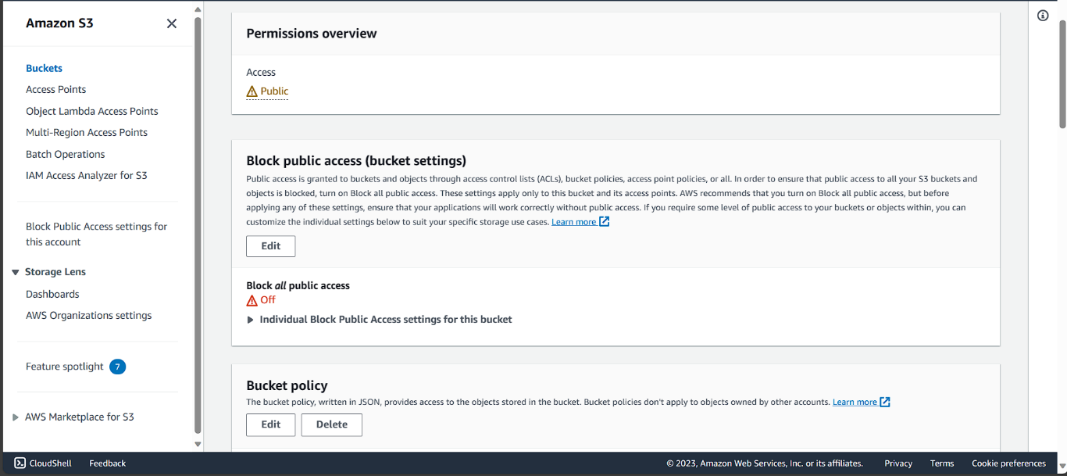

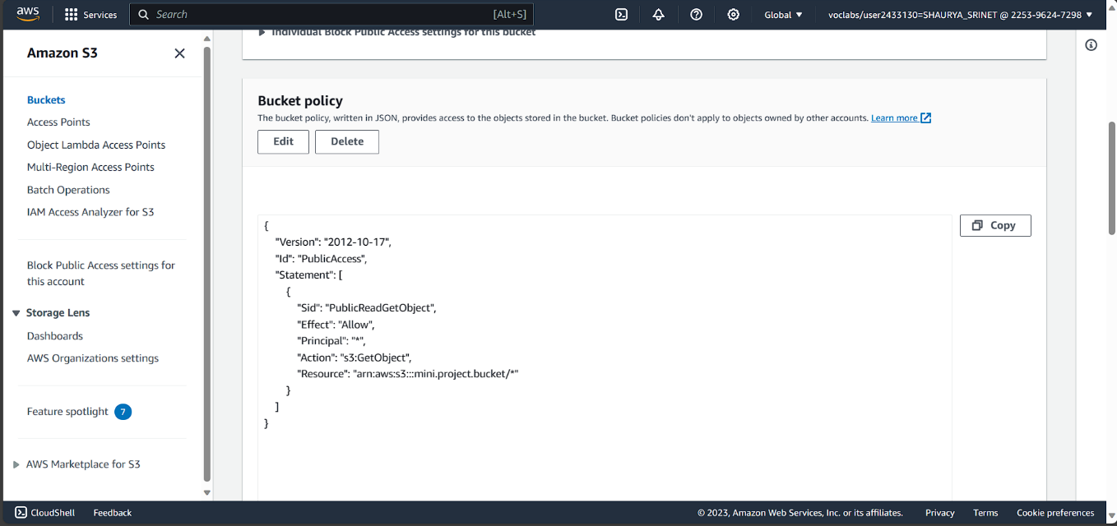

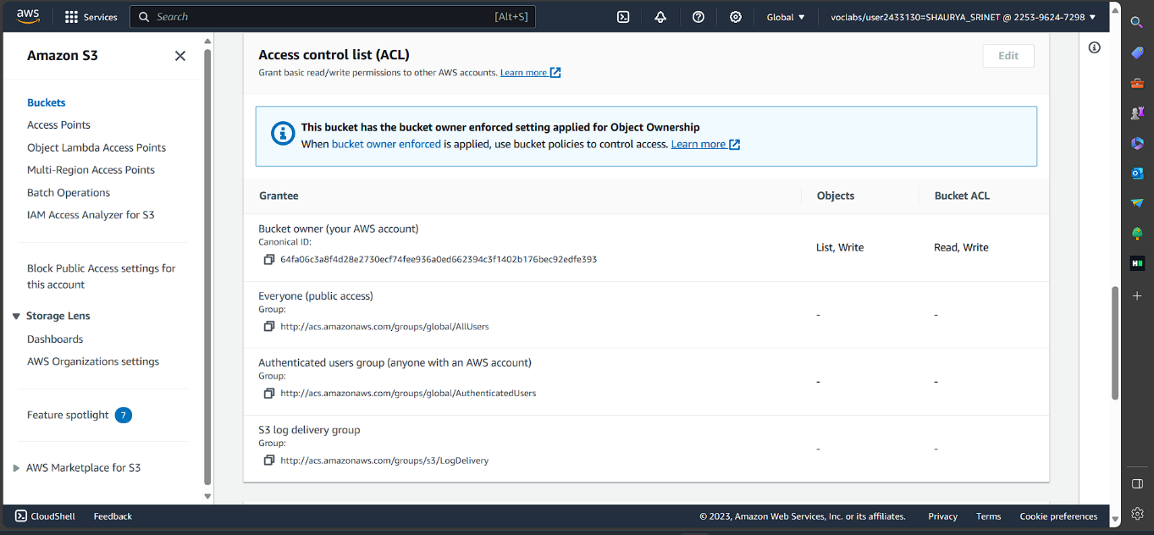

**13**

This image displays the output of the project, which is your portfolio website, successfully deployed and hosted on [bucket.s3-website-us-east-1.amazonaws.com](http://mini.project.bucket.s3-website-us-east-1.amazonaws.com/) (AWS domain) through the Amazon S3 bucket. It showcases your professional portfolio, providing viewers with insights into your work, skills, and achievements. The website's appearance and content reflect the culmination of the project's efforts, demonstrating your skills and accomplishments in a visually appealing and accessible manner.

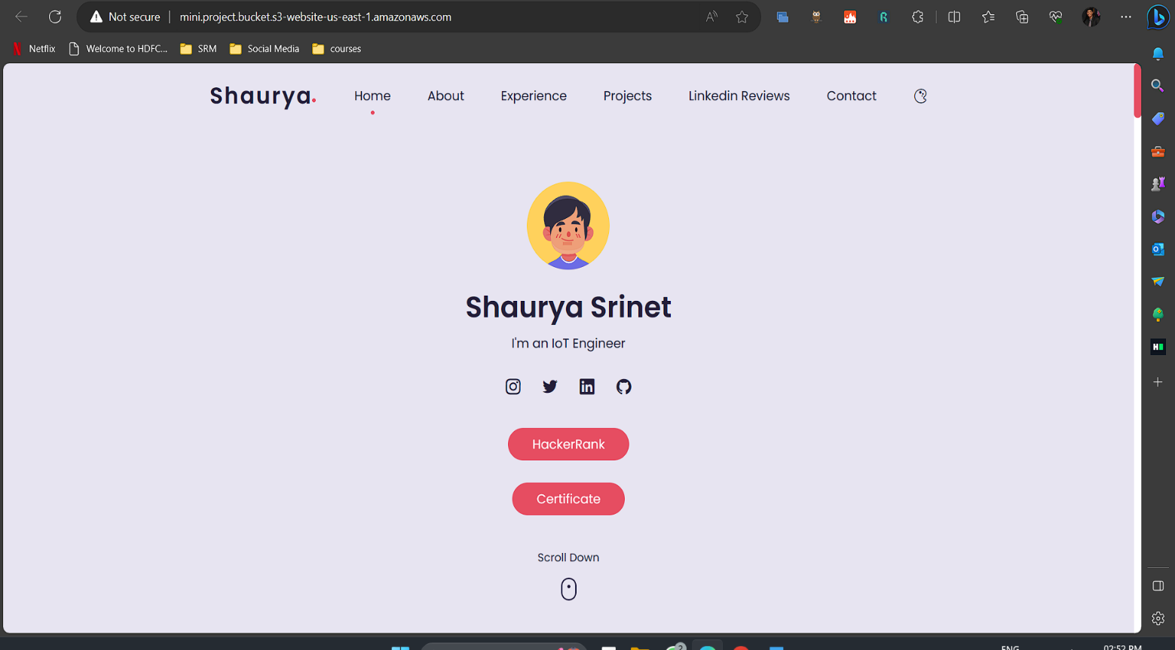

**14**

**CONCLUSION AND RESULT**

In conclusion, this project successfully addressed the challenge of hosting static websites on Amazon S3 while optimizing key aspects of performance, scalability, security, and cost-efficiency. The following key results were achieved:

1. **Efficient Hosting**: Amazon S3 proved to be a reliable platform for hosting static websites, providing excellent availability and low-latency access.
2. **Website Setup**: A sample static website was created and organized, ready for hosting.
3. **Bucket Configuration**: The Amazon S3 bucket was configured correctly, with proper permissions and static website hosting settings in place.
4. **Content Upload**: All website files were successfully uploaded to the S3 bucket.
5. **Scalability and CDN Integration**: Amazon CloudFront was integrated as a CDN, improving website performance and user experience.
6. **Security Measures**: Access controls and encryption were implemented, enhancing the security of the hosted website.
7. **Cost Optimization**: Effective cost management strategies were applied, ensuring the hosting remained cost-efficient.
8. **Performance Testing**: Rigorous performance testing was conducted, resulting in an optimized, fast-loading website.
9. **Documentation and User Guide**: A comprehensive guide was prepared, enabling others to replicate the hosting process with ease.

In summary, this project achieved the goal of hosting static websites on Amazon S3 while maximizing key performance metrics, ensuring scalability, enhancing security, and optimizing costs, all while providing a clear and replicable guide for future use.

**15**

**REFERENCES**

[1] M. B. D'Souza, "Deploying a Static Website on AWS S3," Dev.to, [Online]. Available: https://dev.to/markbdsouza/deploying-a-static-website-on-aws-s3-5am8. [Accessed: Oct. 18, 2023].

[2] Amazon Web Services, "Hosting a Website on Amazon S3," [Online]. Available: https://docs.aws.amazon.com/AmazonS3/latest/userguide/HostingWebsiteOnS3Setup.html. [Accessed: Oct. 18, 2023].

[3] Tiamatt, "AWS Project Module 1 - Host a Static Website on AWS S3 via CloudFormation," Dev.to, [Online]. Available: https://dev.to/tiamatt/aws-project-module-1-host-a-static-website-on-aws-s3-via-cloudformation-2pa2. [Accessed: Oct. 18, 2023].

**16**